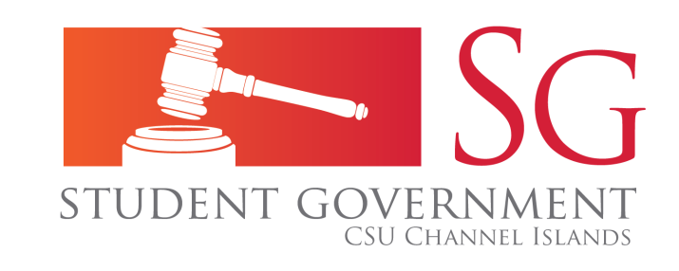 | Student Government Senate Agenda  Wednesday, September 10, 2014  9:00 a.m. – 11:00 a.m.  Student Union Coville Conference Room

Notice
- NOTICE IS HEREBY GIVEN to the general public and to all members of the CSU Channel Islands Student Government that:

A meeting of the Student Government Senate will be held on Wednesday, September 10th , 2014 at 9:00 a.m. at California State University Channel Islands, Student Union Conference Room (room 1080), located at One University Drive, Camarillo, CA 93012, to consider and act upon the following matters:
Call to Order
- Call to Order
- Roll Call
  - President – Vanessa Bahena
  - Vice President – Sara Sanders
  - Senate
    - James Forrester
    - John Slagboom
    - Tyler Smock-Lombardi
    - Garret Snyder
    - Marcus Wurtz
    - Alex Yepez
    - John Butzer
  - Executive.
    - Director of Operations –
    - Director of External Affairs -
    - Director of Recruitment and Retention –
    - Director of Events – Samantha Albert
    - Chief of Staff –
    - Interns –
      - Angelica Garibo
      - Tommy Hatfield
    - General Members -
      - Agustin Rangel-Gonzalez
      - Elizabeth Salgado
      - Monique Reyna
      - Stephanie Chavez
      - Ray Visiaz
    - Advisor – Genesis DeLong
    - Members of the public

- Approval of the Agenda
- Approval of the Minutes (8/27 and 9/3)

Public forum
Public forum is intended as a time for any member of the public to address the Senate on issues affecting any student(s) and/or organizations of California State University Channel Islands.

Business
- Unfinished Business
  - Informational Item
    - Parking Update (Vanessa Bahena)
  - Discussion Item
  - Action Item
- New Business
  - Informational Item
    - What is CSSA? And CSSA Report (Vanessa Bahena)
  - Discussion Item
    - Club/Organization Non-discrimination Policy
    - Policy Agenda Draft
  - Action Item
    - Thank you from Retreat
    - Commuters and Veterans Senator Appointment (Chris Zaki)
Reports
- President’s Report
- Vice President’s Report
- Senator Reports
- Executive Reports
- ASI Board Report
- Academic Senate Report

Adjournment
- Public Forum
- Adjournment

