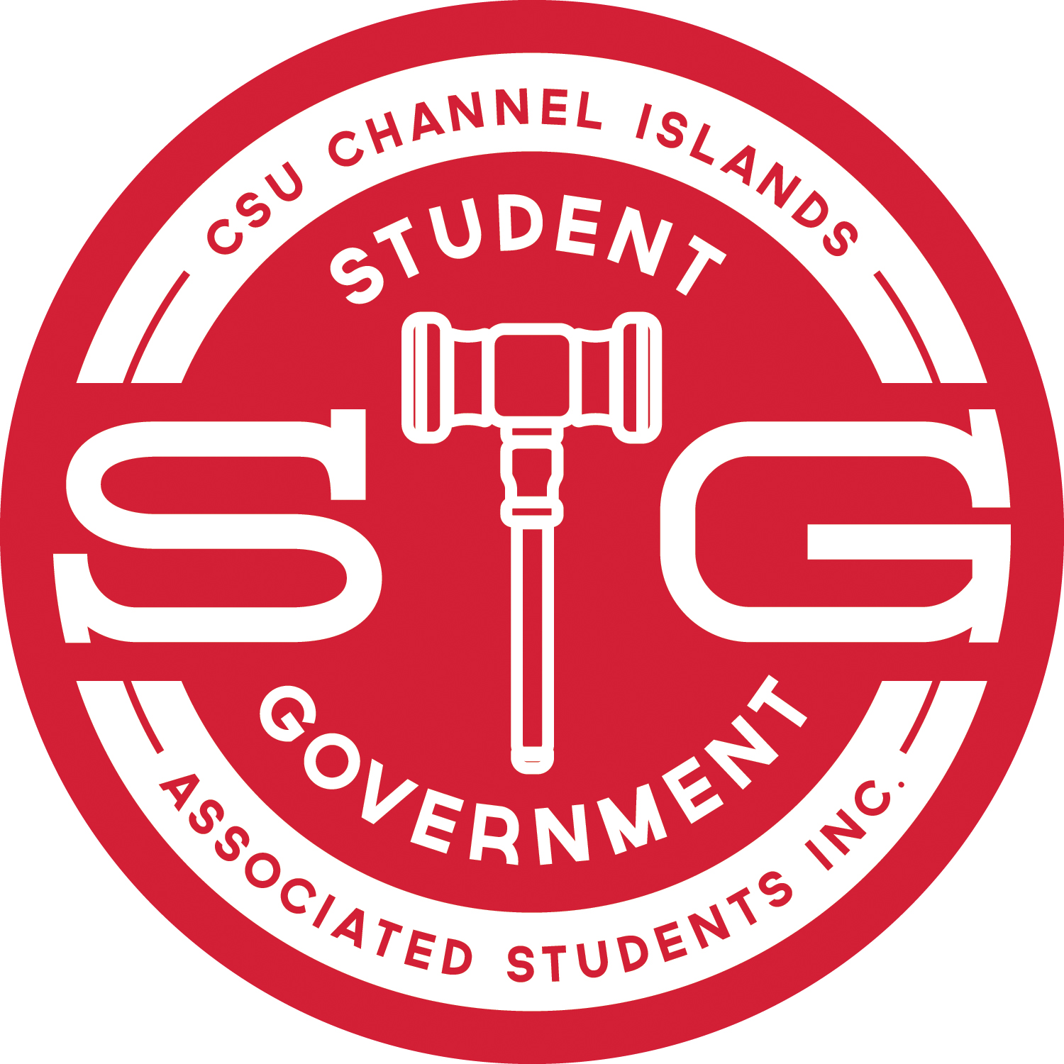 | INTERNAL AFFAIRS COMMITTEE REPORT  Internal Affairs Committee Chair, Chief Justice Brandon J. Burns  April 21, 2017  brandon.burns490@myci.csuci.edu

IAC REPORT
On 04/19/2017 at 6:00pm the Internal Affairs Committee held a regularly scheduled meeting and moved forward as follows:
- The IAC has read through the Bylaws in their entirety over the course of three meetings and is now working to fix the numerous issues identified by the IAC. At this meeting, the IAC is working on a Bill to formally address these issues. A vote is likely to take place at the next meeting on 04/26/2017.

