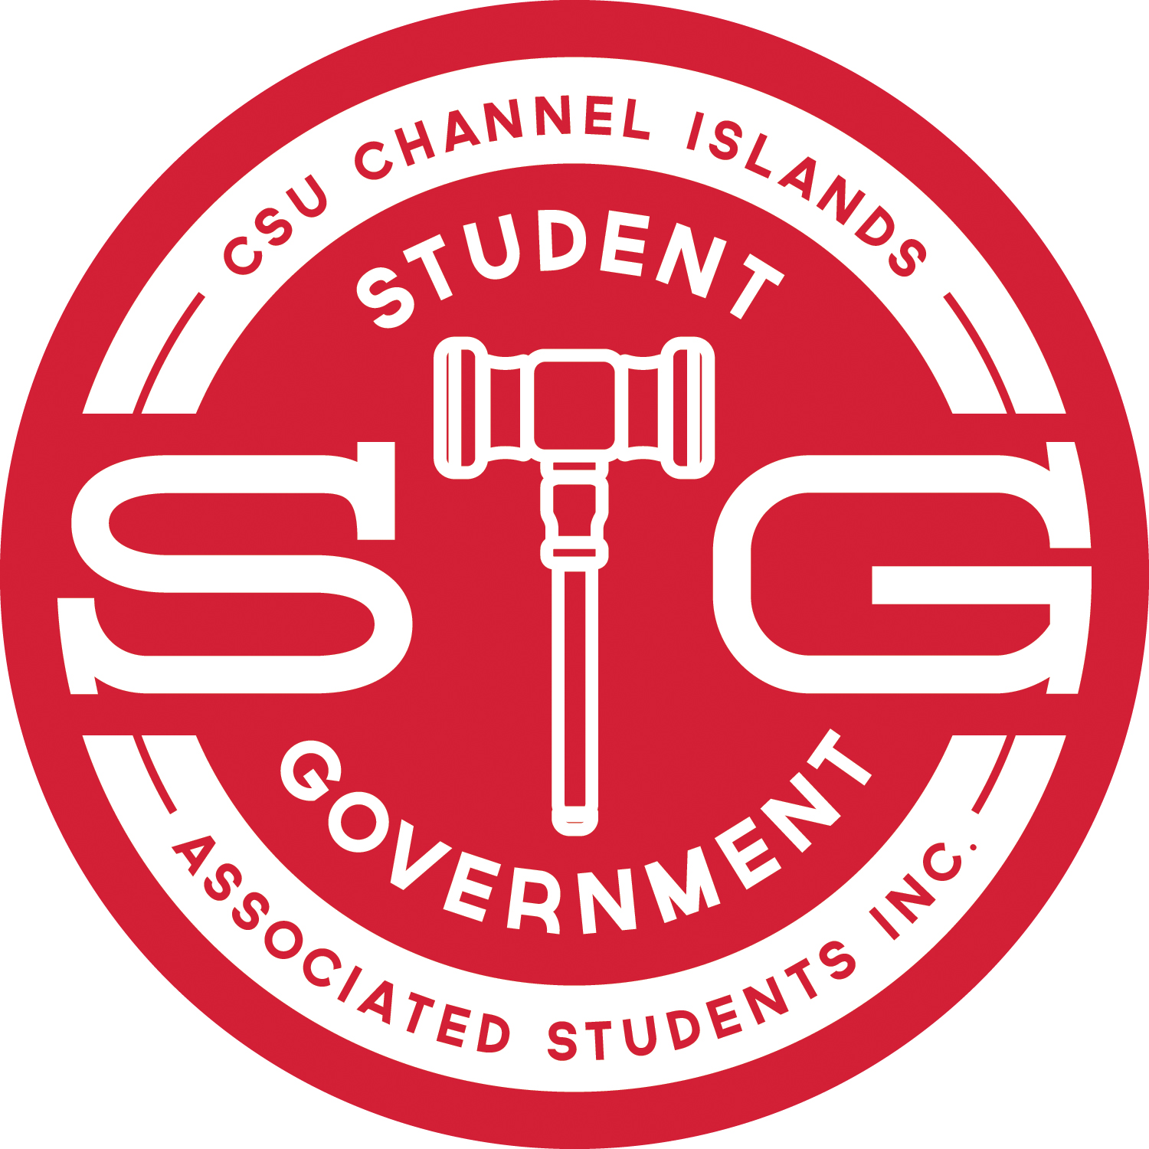 | INTERNAL AFFAIRS COMMITTEE REPORT  Internal Affairs Committee Chair, Brandon Burns  March 17, 2017  brandon.burns490@myci.csuci.edu

IAC REPORT
On 3/17/2017 at 1:30pm the Internal Affairs Committee held a Special Meeting and moved forward as follows:
- Discussed that the SG Bylaws need to be revised and formalized. Specifically, the IAC discussed that: The Bylaws have gone through a number of changes that may not have been properly made. After much investigation, ASI advice, and today’s IAC discussion, it appears that such issues would be solved by formally approving an entire set of Bylaws. The IAC has discussed addressing this issue by making a number of immediately necessary changes to the Bylaws and then sending a whole set of Bylaws to the Senate for a vote. Simultaneously, the IAC discussed working towards an overhaul of the Bylaws. That is to say: in order to address the immediate needs of Student Government, the IAC will develop an acceptable set of Bylaws to the Student Government; while, simultaneously, developing a plan to theoretically improve Student Government Bylaws for the future.
- The IAC discussed possible times for future IAC Meetings. At our next Special Meeting (TBD) we will formally vote on a general meeting time for the remainder of the semester. Based upon discussion, these meetings will likely take place on Wednesdays from 6:00pm-10:00pm.
- Associate Justice Jorge Robles was appointed to the position of Deputy Chair of The Internal Affairs Committee.
- More detailed information will follow, once the IAC Minutes have been approved at the following IAC Meeting.

